*Florida International University*

*School of Computing and Information Sciences*

Software Engineering Focus

Feature Document

User Story ID #697 Implement Adding Objects to Cauldron (Puzzle 1)

**Name:** Armando Carrasquillo

**Team Member(s):** Armando Carrasquillo, Daniel Perez, Santiago Bolivar

**Project:** VR-Gaming to Broad Participation in CS

**Product Owner(s)**: Francisco Ortega

**Mentor(s)**: Francisco Ortega

**Instructor**: Masoud Sadjadi

**User Story Name: Implement Adding Objects to Cauldron (Puzzle 1)**

* Description: As a developer, I want to implement a function for the user to add potions to a cauldron in Unreal, so that the user can work on the puzzle.

Acceptance Criteria

* Verify that the function recognizes when objects are placed in the cauldron.
* Verify that the function recognizes the type of object that was added in the cauldron.
* Verify that the function is keeping record of the potions that are added.
* Verify that the function deletes the object after the object type was recognized.
* Verify that the function warns the user when an incorrect object is added in the cauldron.

**Use Case**

* Name: Place Object in Cauldron
* Actor: User
* Preconditions: The user is able to move objects around.
* Description <Flow of events>:

1. The user grabs an object in the room.
2. The user places the object in the cauldron.
   1. If the object is not a potion, then warn the user.
   2. If the potion was already added, then warn the user.
   3. If the potion was not added, then record it.
3. The object gets deleted from the cauldron.

**Use Case Diagram**

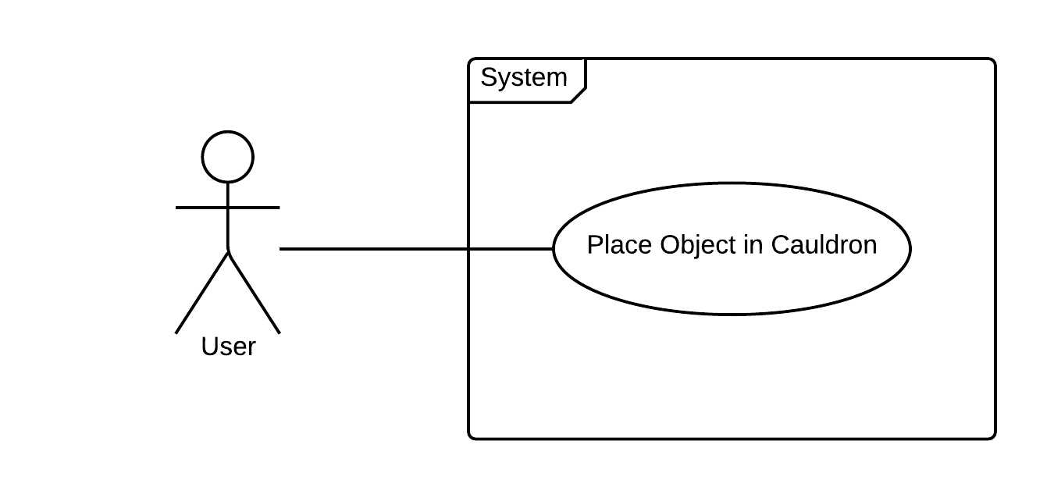

**Sequence Diagram**

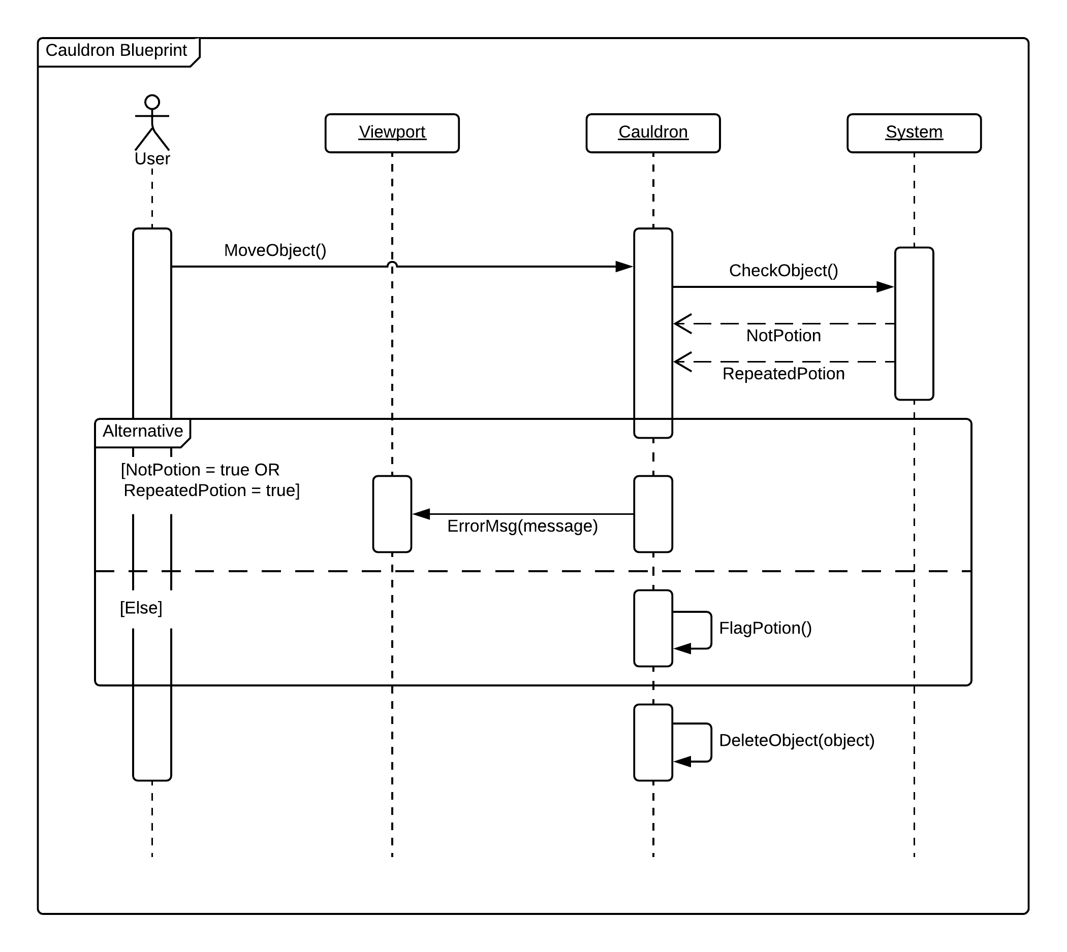

**Class Diagram**

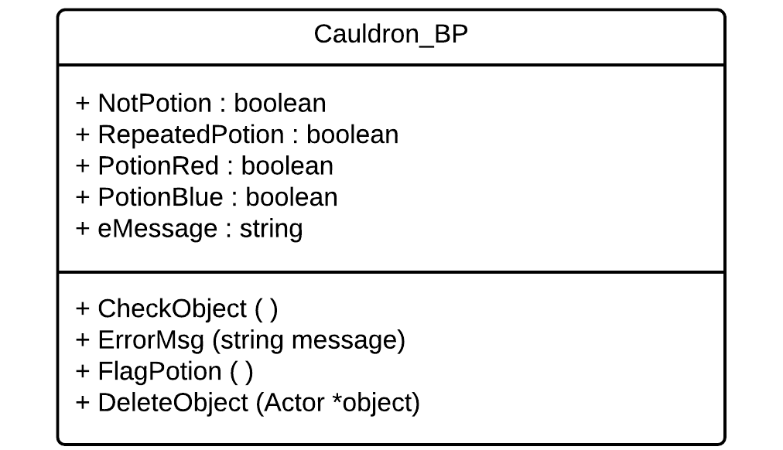

**Unit Test**

* Test case ID: identify_object_p1
* Description/Summary of Test: Cauldron identifies the type of object that is placed within it.
* Pre-condition: User places object in cauldron.
* Expected Results: Identifies if the object is a potion, a player, or a miscellaneous object.
* Actual Result: Identified if the object is a potion, a player, or a miscellaneous object.
* Status (Fail/Pass): Pass
* Test case ID: record_potion_p1
* Description/Summary of Test: Keeps track if a necessary potion object was placed in the cauldron.
* Pre-condition: Place a potion object in the cauldron.
* Expected Results: If a red or blue potion object is placed in the cauldron. The boolean for the respective potion is set to true.
* Actual Result: When a red or blue potion object is placed in the cauldron. The boolean for the respective potion is set to true.
* Status (Fail/Pass): Pass
* Test case ID: delete_object_p1
* Description/Summary of Test: Deletes the object after the necessary action has been done.
* Pre-condition: Object has been identified and set to be deleted.
* Expected Results: Deletes the object.
* Actual Result: The object is deleted.
* Status (Fail/Pass): Pass

**Visual User Guide**

